Hello sir,

Greetings from CRIF High Mark!!!
As discussed over the call about uploading the data query.
We are providing you the file format, the steps to upload the data, User ID and the link to login SFTP.
We request you to provide all the Required field mentioned in the sheet so that the data will be uploaded smoothly. We also request you to Submit the data on monthly basis and in the same format.
For any clarification, kindly contact us on 020-67157787.

Your FTP details are as under: The FTP site is a highly secured dedicated web link maintained by CRIF High Mark to securely upload data.

Member Id:
Login ID:
Password:
Web link: | https://sftp.crifhighmark.com

Login Issue Query : If you are facing any login issues or if you need Password for data upload and report pull out please send an email to productsupport@crifhighmark.com
How to upload data files: Upon login, please follow the steps as described here:
1. Click on Bureau Data Submission:-
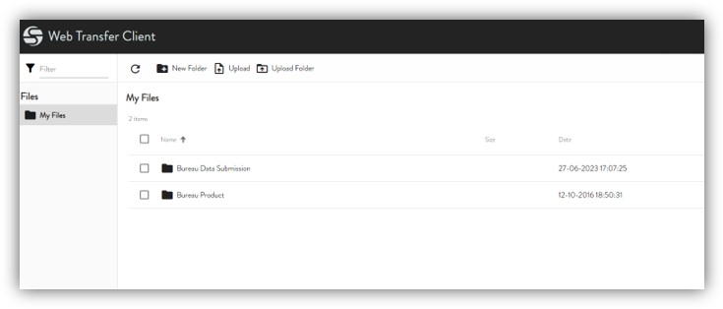

2. Then you need to click on Prod Data
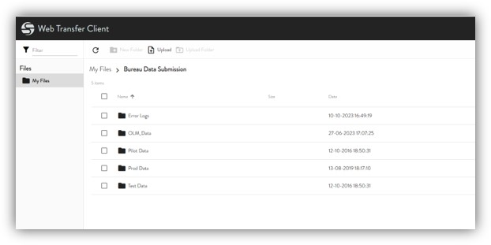

3. Then you need to click on MFI.
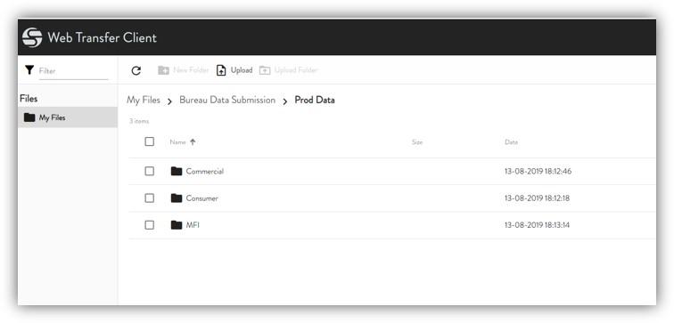

4. Then select your submission whether Daily, Weekly or Monthly.
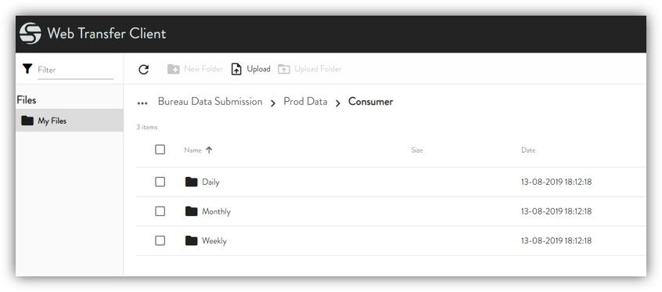

5. You need to then click on File à Upload

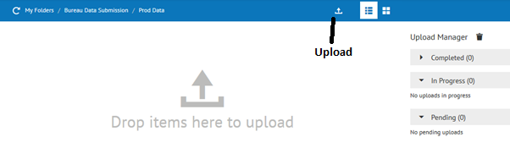

In case the above options do not appear to you please DRAG and DROP the file.
Ones you have uploaded the data please send an intimation mail to mfi_operations@crifhighmark.com

